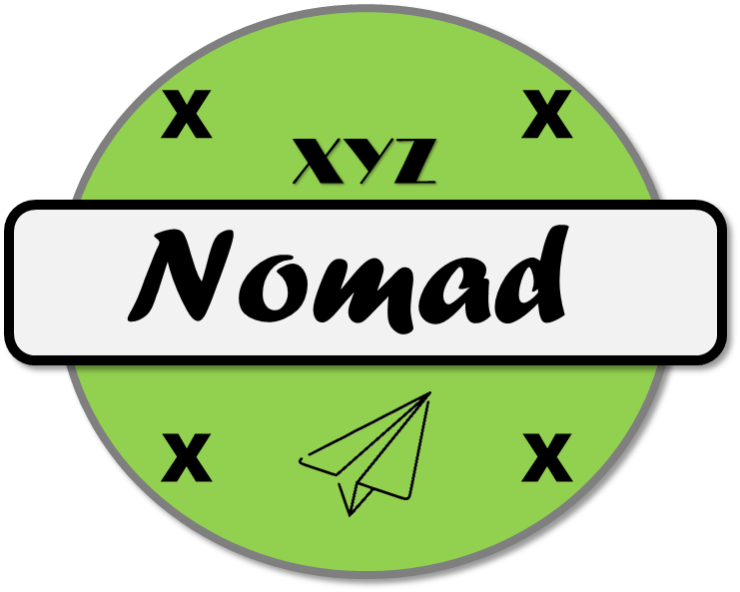

Initial Payload Testing

16 September 2019

Version 1.1

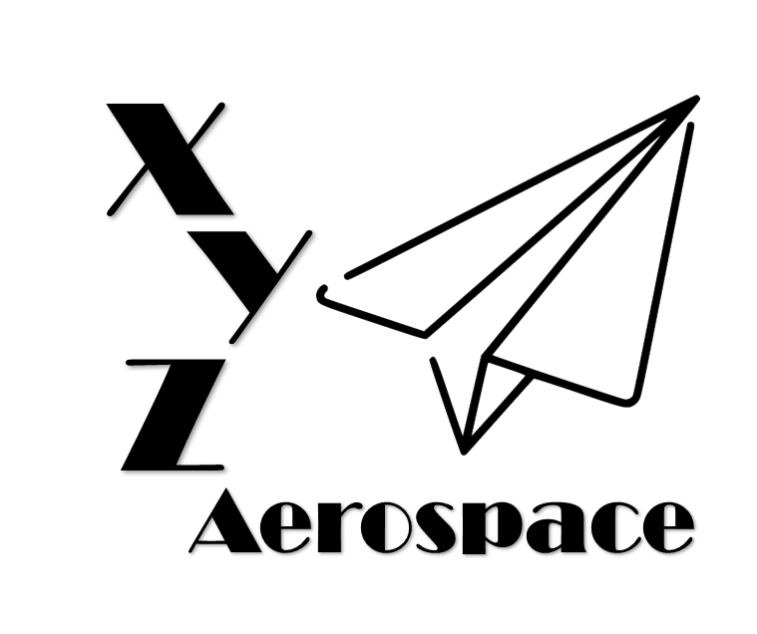

645 Colonel Glenn Blvd

Dayton, Ohio

DISCLAIMER: This document has been produced to support training and experimentation ONLY. It does not represent any system, real or planned. No United States Government resources were used to produce this document.

**THIS PAGE IS INTENTIONALLY BLANK**

Contents

1. Introduction 5

2. Ground Control 5

2.1. Test 06-01 5

3. Full Motion Video 5

3.1. Test 07-01 6

3.2. Test 07-02 6

3.2.1. Sensor Performance 6

3.2.2. Sensor Performance (High Resolution) 6

3.2.3. Sensor Performance (Long Range) 7

3.3. Test 07-03 7

3.3.1. Nighttime Performance 7

4. Payload Link 7

4.1. Test 08-01 7

5. Mission Control Software 8

5.1. Test 09-01 8

**THIS PAGE IS INTENTIONALLY BLANK**

1. Introduction

The Nomad system is modified from the legacy Wanderer UAV, with the majority of the air vehicle and associated vehicle control consistent between the two variants. However, the vehicle payloads and ground control station have been tailored for the OTSS-E mission. The initial round of payload testing was conducted in the middle of the program to evaluate the Full Motion Video (FMV) system, as well as the prototype Deployable Ground Control Station (DGCS). Multiple tests were conducted between August and September 2019.

1. Ground Control
   1. Test 06-01

The first payload test conducted was Test 06-01, which was designed to test the prototype DGCS. During these tests, the Nomad-01 air vehicle was controlled by the DGCS v1 in simple maneuvers.

|  |  |
| --- | --- |
| Test 06-01 Metadata |  |
| Date | 18 August 2019 |
| Location | Dayton, Ohio |
| Altitude | 900 ft MSL |
| Configuration | Nomad-01-02 |

During the tests, the operator controlled the air vehicle and was able to monitor:

* Airspeed (absolute)
* Altitude (in ft AGL)
* Heading
* Roll Angle
* Pitch Angle
* Yaw Angle
* Vertical Speed
* Lateral Speed

In addition, the operator was able to command the vehicle to maintain position. This was accomplished with the air vehicle in direct control mode by the operator releasing control of the control stick. After, the vehicle maintained position at 300 ft AGL.

1. Full Motion Video

Testing of the FMV system was accomplished in two phases. The first phases was sensor control characterization in the Dayton, Ohio local area. The second phase was on Wright-Patterson Air Force Base’s imaging target to enable quantitative characterization of the sensors in both day and night.

* 1. Test 07-01

Test 07-01 was conducted to demonstrate positive control of the FMV sensor prior to executing qualitative tests at WPAFB. During the test, the air vehicle was held at 300 ft AGL, and the camera turret was moved to different targets.

|  |  |
| --- | --- |
| Test 07-01 Metadata |  |
| Date | 25 August 2019 |
| Location | Dayton, Ohio |
| Altitude | 900 ft MSL |
| Configuration | Nomad-01-02 |

During this test phase, the operator was able to pan, tilt and zoom the camera without restrictions. The camera was able to pan 360 degrees, and tilt from +10 to -90 degrees.

* 1. Test 07-02

Test 07-02 was executed on WPAFB’s resolution targets, which have a long lineage of testing optical sensors. Both the air vehicle and DGCS were located on WPAFB Area B during testing, which was conducted via line of sight.

|  |  |
| --- | --- |
| Test 07-02 Metadata |  |
| Date | 30 August 2019 |
| Location | WPAFB, Ohio |
| Altitude | 980 ft MSL |
| Configuration | Nomad-01-02 |

* + 1. Sensor Performance

The initial imaging test was conducted at 500 ft AGL, with a ground range to target of 50 feet.

|  |  |
| --- | --- |
| Test 07-02-01 |  |
| Time | 1330L |
| Slant Range to Target | 502 feet |
| Pointing Accuracy | 1.78 degree |
| Resolution | 0.18 meter |
| Framerate | 28 fps |

* + 1. Sensor Performance (High Resolution)

The high resolution imaging test was conducted at 500 ft AGL, with a ground range to target of 700 feet.

|  |  |
| --- | --- |
| Test 07-02-02 |  |
| Time | 1400L |
| Slant Range to Target | 860 feet |
| Pointing Accuracy | 1.75 degree |
| Resolution | 0.25 meter |
| Framerate | 28 fps |

* + 1. Sensor Performance (Long Range)

The high resolution imaging test was conducted at 500 ft AGL, with a ground range to target of 3000 feet.

|  |  |
| --- | --- |
| Test 07-02-03 |  |
| Time | 1430L |
| Slant Range to Target | 3050 |
| Pointing Accuracy | 1.80 degree |
| Resolution | 0.75 meter |
| Framerate | 28 fps |

* 1. Test 07-03

Test 07-02 was executed on WPAFB’s resolution targets during the night. Both the air vehicle and DGCS were located on WPAFB Area B during testing, which was conducted via line of sight.

|  |  |
| --- | --- |
| Test 07-03 Metadata |  |
| Date | 30/31 August 2019 |
| Location | WPAFB, Ohio |
| Altitude | 980 ft MSL |
| Configuration | Nomad-01-02 |

* + 1. Nighttime Performance

The night imaging test was conducted at 500 ft AGL, with a ground range to target of 500 feet. During testing the average illuminance was 0.83 lux. Additionally, the operator was able to switch between imaging modes, going back and forth between day and night camera modes.

|  |  |
| --- | --- |
| Test 07-03-01 |  |
| Time | 2350L |
| Illuminance | 0.83 lux |
| Slant Range to Target | 710 ft |
| Resolution | 1.1 meter |
| Framerate | 26 fps |

1. Payload Link
   1. Test 08-01

Test 08-01 tested the payload link performance. Testing was conducted in Dayton, Ohio. Some testing was conducted outside line of sight of the DCGS, which required the use of a helicopter chase vehicle to ensure safe test performance.

|  |  |
| --- | --- |
| Test 08-01 Metadata |  |
| Date | 6 September 2019 |
| Location | Dayton, Ohio |
| Altitude | 900 ft MSL |
| Configuration | Nomad-01-02 |

The tests showed a maximum range of 1.4 miles using the primary payload data link. During testing the team utilized multiple frequencies to achieve the optimal range and data rates, before selecting the final configuration. In this configuration, the payload link achieved 38 mb/s up and down. As part of the testing, it was found that the payload link was very susceptible to line of sight interference when objects were located between the ground station and the air vehicle. To combat this, the team utilized a 10 foot tall antenna mast to elevate the antennas. This mast will not be a part of the standard deployment, but will be available as peculiar equipment as required.

|  |  |
| --- | --- |
| Test 08-01-01 |  |
| Time | 1300L |
| RANGE | 1.4 miles |
| dATA rATE | 38 mb/s |

1. Mission Control Software
   1. Test 09-01

The final test for the initial payload was to evaluate the performance of mission control software enabled by the Nomad-01 air vehicle. This included the display of system health and status, as well as partial testing of the Common Operating Picture (COP) and route planner.

|  |  |
| --- | --- |
| Test 09-01 Metadata |  |
| Date | 8 September 2019 |
| Location | Dayton, Ohio |
| Altitude | 900 ft MSL |
| Configuration | Nomad-01-02 |

During testing, the operator was able to successfully monitor system health and status for the air vehicle. The status page showed the current state of the systems, and allowed the operating to initiate Built In Test (BIT) for each system.

The operator also evaluated the COP, which displayed both the current route and Blue Force (friendly) assets. The Blue Force data was ingested via the external connection, which provided simulated data for the test. In addition, the user operator was able to plan a new route using the COP interface.